**Summer Assignment - Unit 1 The Living World**

**Welcome to AP/IB Environmental Science! This summer assignment will get us jump started on the year. Most of the content should be review from Biology. Resources for the content you do not remember can be found at the bottom of the assignment.**

**\*\*\*There will be a quiz on this content when you get to class, and the Unit 1 test will be week 2.**

**Predator Prey**

1) Define Predator.

2) Define Prey.

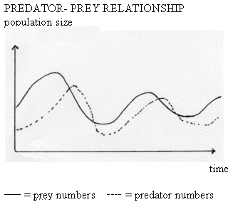3) Describe the trends from observations of the figure to the left:

**Symbioses**

4) Define Symbiosis.

5) Fill in the chart below on the different types of symbioses.

|  |  |  |  |
| --- | --- | --- | --- |
| **Symbiosis Type** | **Species 1 Interaction (Beneficial, Harmful, or Neutral)** | **Species 2 Interaction**  **(Beneficial, Harmful, or Neutral)** | **Give a Real World Example** |
|  |  |  |  |
|  |  |  |  |
|  |  |  |  |

**Competition and Resource Partitioning**

6) What is competition?

7) How does competition sometimes lead to resource partitioning?

8) Compare interspecific to intraspecific competition.

**Terrestrial Biomes**

9) Define the term biodiversity.

10) Define the term biome.

11) Sketch and/or label the following on the map of the world below:

* 1. the equator
  2. the tropic of Cancer and the tropic of Capricorn
  3. the Mid-Atlantic Ridge
  4. the location of suppressed upwelling characteristic of the occurrence of El Niño
  5. 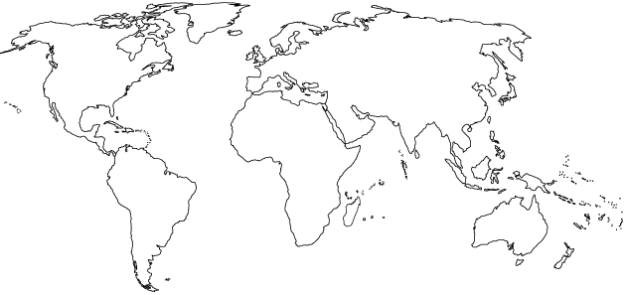the location of China, India, Ethiopia, Brazil, Bangladesh, and Fremont

12) Fill in the table below about the different terrestrial biomes of the world.

|  |  |  |  |
| --- | --- | --- | --- |
| **Type of Biome** | **Typical Location** | **Typical Climate** | **Characteristic adaptations for survival** |
| Tropical Rain Forest |  |  | Plants –  Animals – |
| Temperate Deciduous Forest |  |  | Plants –  Animals – |
| Taiga (Boreal) Forest |  |  | Plants –  Animals – |
| Tropical Grasslands (Savanna) |  |  | Plants –  Animals – |
| Temperate Grassland (Prairie) |  |  | Plants –  Animals – |
| Tundra  (Cold Grassland) |  |  | Plants –  Animals – |
| Desert |  |  | Plants –  Animals – |

13) For each of the following biomes, identify a specific country in which each biome occurs in relative abundance:

Taiga Desert

Tropical rainforest Temperate grassland

Tropical grassland Coral reef

Temperate deciduous forest Tundra

**Aquatic Biomes**

14) Fill in the table below about the different aquatic biomes of the world.

|  |  |  |  |
| --- | --- | --- | --- |
| **Type of Biome** | **Typical Location** | **Typical Climate** | **Characteristic adaptations for survival** |
| Coral Reef |  |  | Plants –  Animals – |
| Open Ocean |  |  | Plants –  Animals – |
| Kelp Forest |  |  | Plants –  Animals – |
| Estuary/Wetland |  |  | Plants –  Animals – |

**Food Chains**

17) Identify three examples of biotic components of an ecosystem and three examples of abiotic components of an ecosystem.

(1) (1)

Biotic: (2) Abiotic: (2)

(3) _____________________ (3) _________________________

18) Diagram a simple food chain in the space below. Label the trophic levels and illustrate the Rule of 10 with each trophic level. Start with 1,000,000 kCal in the primary producer level.

19) What happens when a predator is removed from the food chain or web?

**1st and 2nd Law of Thermodynamics**

20) Define the First Law of Thermodynamics

-Example

21) Define the Second Law of Thermodynamics

-Example

***Define Primary Productivity -***

**Resources: Unit 1 The Living World Review Videos**

**Textbook Modules 🡪**

**Mr. Andersen, Bozeman Biology**

[007 - Ecosystem Ecology](http://www.bozemanscience.com/ap-es-007-ecosystem-ecology)    
[008 - Energy Flow in Ecosystems](http://www.bozemanscience.com/ap-es-008-energy-flow-in-ecosystems)    
[009 - Ecosystem Diversity](http://www.bozemanscience.com/ap-es-009-ecosystem-diversity)

[010 - Natural Ecosystem Change](http://www.bozemanscience.com/ap-es-010-natural-ecosystem-change)

**Amoeba Sisters**

[Ecological Relationships](https://www.youtube.com/watch?v=rNjPI84sApQ)

**Crash Course**

[Population Ecology - Crash Course Biology #2](https://www.youtube.com/watch?v=RBOsqmBQBQk&list=PL8dPuuaLjXtNdTKZkV_GiIYXpV9w4WxbX&index=2):

[Community Ecology: Feel the Love Crash Course Ecology #4](https://www.youtube.com/watch?v=GxE1SSqbSn4&list=PL8dPuuaLjXtNdTKZkV_GiIYXpV9w4WxbX&index=4)

[Community Ecology II: Predators Crash Course Ecology #5](https://www.youtube.com/watch?v=mFDiiSqGB7M&list=PL8dPuuaLjXtNdTKZkV_GiIYXpV9w4WxbX&index=5)

[Ecological Succession: Change is Good Crash Course Ecology #6](https://www.youtube.com/watch?v=jZKIHe2LDP8&list=PL8dPuuaLjXtNdTKZkV_GiIYXpV9w4WxbX&index=6)

[Ecosystem Ecology: Links in the Chain Crash Course Ecology #7](https://www.youtube.com/watch?v=v6ubvEJ3KGM&list=PL8dPuuaLjXtNdTKZkV_GiIYXpV9w4WxbX&index=7)

**HHMI BioInteractive**

[Some Animals are More Equal Than Others: Trophic Cascades](https://www.youtube.com/watch?v=hRGg5it5FMI)

**Khan Academy**

[Ecology Introduction](https://www.youtube.com/watch?v=OfV3VNgjpvw&list=PLbjyLFA2XFZyvLJTz-oWEUURQtwnf32eP)

[Ecosystems and Biomes](https://www.youtube.com/watch?v=A495e31cDdE&list=PLbjyLFA2XFZyvLJTz-oWEUURQtwnf32eP&index=2)

[Flow of Energy and Matter Through Ecosystems](https://www.youtube.com/watch?v=TitrRpMUt0I&list=PLbjyLFA2XFZyvLJTz-oWEUURQtwnf32eP&index=3)

[Interactions Between Populations](https://www.youtube.com/watch?v=q2zdiLn3gSE&list=PLbjyLFA2XFZyvLJTz-oWEUURQtwnf32eP&index=4)

[Organism Life History and Fecundity](https://www.youtube.com/watch?v=mAdUjImDx58&list=PLbjyLFA2XFZyvLJTz-oWEUURQtwnf32eP&index=6)

[Exponential and Logistic Growth in Populations](https://www.youtube.com/watch?v=KyAKEisg2PQ&list=PLbjyLFA2XFZyvLJTz-oWEUURQtwnf32eP&index=9)

[Predator Prey Cycle](https://www.youtube.com/watch?v=NYq2078_xqc&list=PLbjyLFA2XFZyvLJTz-oWEUURQtwnf32eP&index=10)

[Ecological Succession](https://www.youtube.com/watch?v=d7xbyNSxxrI&list=PLbjyLFA2XFZyvLJTz-oWEUURQtwnf32eP&index=11)

[Population Regulation](https://www.youtube.com/watch?v=6IS_M6CX7FE&list=PLbjyLFA2XFZyvLJTz-oWEUURQtwnf32eP&index=12)